February Recipe: A Valentine’s Day Favorite

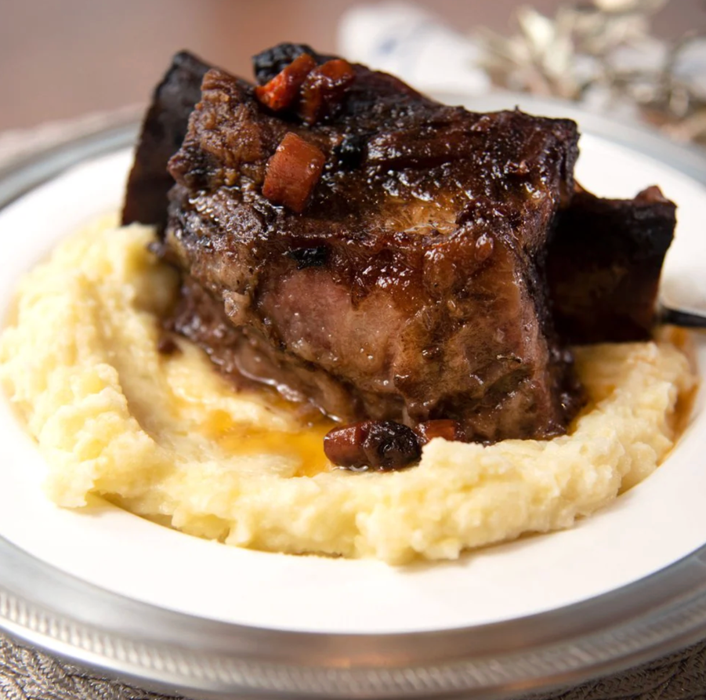
Valentine’s Day is a good reminder that some things are worth slowing down for.
Red Wine–Braised Short Ribs are a classic, comfort-forward dish that rewards patience. Slowly braised with garlic, herbs, and red wine, the result is rich, tender, and perfect for sharing.

Serves
4–6

Ingredients
- 4–5 lb bone-in beef short ribs
- Kosher salt and freshly ground black pepper
- 2 tbsp olive oil
- 1 large onion, diced
- 2 carrots, diced
- 2 celery stalks, diced
- 4 cloves garlic, smashed
- 2 tbsp tomato paste
- 2 cups dry red wine (Cabernet Sauvignon, Merlot, or Syrah)
- 2 cups beef stock
- 2–3 sprigs fresh thyme
- 1–2 sprigs fresh rosemary
- 2 bay leaves

Optional aromatics
- 1 tsp smoked paprika or crushed black peppercorns
- 1 strip orange peel (adds subtle warmth)

Instructions
- Season & Sear
Pat short ribs dry and season generously with salt and pepper. Heat olive oil in a large Dutch oven over medium-high heat. Sear ribs on all sides until deeply browned (about 3–4 minutes per side). Remove and set aside.
- Build the Base
Lower heat to medium. Add onion, carrots, and celery to the pot. Cook 6–8 minutes, scraping up browned bits, until vegetables soften. Add garlic and tomato paste; cook 1–2 minutes until fragrant and brick-red.
- Deglaze
Pour in red wine, stirring to release all fond from the bottom. Simmer 8–10 minutes until the wine reduces by about half.
- Braise
Return short ribs to the pot. Add beef stock until ribs are mostly submerged. Add thyme, rosemary, bay leaves, and any optional aromatics. Bring to a gentle simmer.
- Slow Cook
Cover and transfer to a 325°F (165°C) oven. Braise for 2½–3 hours, turning ribs once halfway, until fork-tender.
- Finish the Sauce
Remove ribs and tent loosely with foil. Skim excess fat from the surface. Simmer the sauce on the stovetop 10–15 minutes until glossy and slightly thickened. Season to taste.

